**MODULE 4 – Introduction to Policy For EV**

Final Module Quiz

**Questions for Section 4.1**

### Question 1 5 of the 7 following options are public interests. Please check the boxes of the 5 public interests.

1. Public health
2. Public safety
3. The rule of law
4. Government monopolization of natural resources
5. Promoting interests of private companies
6. Equal treatment of all citizens
7. Protection of the environment

Ans. A, B, C, F, G

### Question 2 The Paris climate agreement aims to limit global temperature rise to...

1. 0°C - 0.5°C above pre-industrial levels
2. 1°C - 1.5°C above pre-industrial levels
3. 1.5°C - 2°C above pre-industrial levels
4. 2°C - 3°C above pre-industrial levels

Ans. C

### Question 3 Match the type of problem to the type of government intervention required.

**Government intervention at local level,**

Air pollution due to vehicles in a city

**Government intervention at international level,**

Climate Change

**Government intervention at national level**

Energy security

**Government intervention not required**

Developing low cost affordable EV

### Question 4 Electric vehicles powered by renewable energy sources can contribute to solving a variety of problems in which the public interest is at stake.

Select the 4 problems to which EVs can contribute.

1. Air quality improvement
2. Climate change mitigation
3. Public safety
4. Energy security
5. Economic growth

Ans. A, B, D, E

**Questions for Section 4.2**

### Question 1 How is the U.S. state of California stimulating the use of plug-in hybrids and zero-emission vehicles? Three of the five choices are correct.

1. By allowing the use of special traffic lanes
2. By providing a city-wide electric car sharing service
3. By providing rebates on eligible models
4. Through a lottery providing electric vehicles
5. Through infrastructure, both hydrogen and electric

Ans. A, C, E

### Question 2 Please consider the two statements below.

**A.** Smart mobility strategies of cities include the objective of reducing local pollution.

**B.** Other smart mobility strategies include subsidies for zero-emission vehicles, as well as exclusive and free parking which include the required infrastructure. Also, the government should lead by example and switch to zero emission vehicles themselves.

Read the statements and consider whether these are true or false.

1. Both statements A and B are true.
2. Statement A is true whilst statement B is false.
3. Statement A is false whilst statement B is true.
4. Both statements A and B are false.

Ans. A

### Question 3 Creating policy is generally a trade-off between the interests of different stakeholders and priorities. The European Commision has made a choice in the trade-off between the achieval of energy efficiency, the aim for global leadership and new (risky) technologies, and who is to bear the financial burden.

What did the EU Commision decide?

1. Achieving energy efficiency and global leadership as far as possible, whilst offering a fair deal to consumers of electricity
2. Achieving energy efficiency but not seeking global leadership, allowing consumers to benefit from existing technologies
3. Achieving energy efficiency and global leadership, and burdening the consumer of electricity with the cost of these ambitions

Ans. A

**Questions for Section 4.3**

### Question 1 The electricity infrastructure that we see today is not a consequence of design, rather, it evolved into its current form. Which factors have played a role in its evolution?

1. Changing societal preferences
2. Changing user needs
3. Changing economic conditions
4. Environmental issues
5. New technological developments
6. All the above

Ans. F

### Question 2 Considering the electricity infrastructure as a socio-technical system, which of these actors are part of this system?

1. Transmission system operators
2. Distribution system operators
3. Aggregators
4. Regulatory authorities
5. Users
6. All the above

Ans. F

### Question 3 Governments only have a limited role to play in the evolution of an infrastructure system. It only reinforces societal preferences and technological advancements by providing an institutional framework.

1. True
2. False

Ans. A

### Question 4 Consider the two statements given below and choose the correct option:

**A.** Existing power generation capacity due to coal and nuclear power plants with long lifetime of operation remaining will slow down the transition to renewable sources. This is an example of path dependency.

**B.** The household electricity demand has a peak in the morning (before people go to work) and in the evening (after people come back from work) for all working days. This is an example of emergent behavior.

Select the correct option from the options below:

1. Both statements are true
2. Statement A is true and statement B is false.
3. Statement A is false and statement B is true
4. Both statements are false

Ans. A

**Questions for Section 4.4**

### Question 1 What can governments do to stimulate electric car use? Three of the five options are correct.

1. Create more public charging infrastructure
2. Reduce parking spaces in city centers
3. Safeguard privacy and (cyber)security
4. Implement stimulations for electric car purchases.
5. Reduce the speed limit on highways

Ans. A, C, D

### Question 2 What factors are generally considered when choosing whether to buy an electric or gasoline car? 8 of the 10 are correct.

1. The financial cost of purchase
2. The availability of infrastructure for charging
3. The quality of the brakes
4. The financial cost of operation and maintenance
5. The impact on privacy
6. The range anxiety
7. The total cost of ownership
8. The quality of the tires
9. The social status of an electric car
10. The clean conscience of an electric car

Ans. A, B, D, E, F, G, I, J

### Question 3 Please have a look at the image below. It is the institutional framework by Williamson (2000) which is referenced to in the lecture. Up top are the important values, such as human dignity. These are made more and more specific in the lower levels, until the lowest level is concerned with the value of everyday objects, generally expressed through pricing. Drag each of the items to the corresponding level of institution.

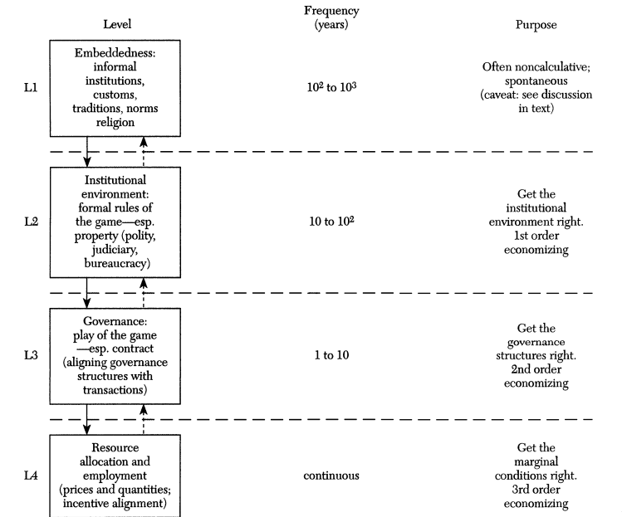

Placed in: Level 1

Items placed here: Clean drinking water and access to electricity are essential to all members of society

Placed in: Level 2

Items placed here: Public services should be universally accessible, through infrastructure and pricing

Placed in: Level 3

Items placed here: Public services are to be organized in a public monopoly

Placed in: Level 4

Items placed here: A regulator should check the quality of the supply

**Questions for Section 4.5**

### Question 1 Use the following image for the next 2 questions. It shows the pollution source contributions to the total PM 10 emissions. Pollution Source PM10

Based on the figure above, for which country/countries is traffic the most important contributor to ambient PM?

1. Africa
2. Canada
3. India
4. USA
5. Nothern China

Ans. A, C, E

### Question 2 Based on the figure above, which countries are not active with domestic fuel burning?

1. Turkey
2. India
3. Nothern China
4. USA

Ans. A

### Question 3 Consider the two statements given below and choose the correct option:

**A.** The distribution network generally is a regulated monopoly, whereas energy suppliers and aggregators are operating in a competitive market.

**B.** While lower level institutions define market rules and regulatory authority, higher level institutions define contracts, technical and operational standards.

Select the correct option from the options below:

1. Both statements are true
2. Statement A is true and statement B is false.
3. Statement A is false and statement B is true
4. Both statements are false

Ans. B

### Question 4 Here you will find a statement and reasoning. State true, if the reasons support the statement, and false, if the reasons don’t support the statement.

Statement: Public transport services in rural areas are generally of a lower quality, certainly in terms of frequency.

Reasoning: In densely populated city areas, providing affordable public transport is a lot easier

than in sparsely populated rural areas.

1. True
2. False

Ans. A

### Question 5 Peer pressure can result in more people willing to shift to an electric vehicle.

1. True
2. False

Ans. A